

AMERICAN INTERNATIONAL UNIVERSITY–BANGLADESH (AIUB)
Dept. of Computer Science
Faculty of Science and Technology
CSC2210: OBJECT ORIENTED PROGRAMMING 2
Fall 2024-2025
Section: [E]
Group No: 0612

Project Report On
Project Name [Let’s Travel]
Supervised By
Kazi Sadia

Submitted By:
Name | ID
1. MD. Nazmus Sadat Numan | 22-48597-3
2. MD Doad | 22-48506-3
3. Hasibul Islam Hasib | 22-48507-3
4.Istiak Ahmmed Shifat | 22-49319-3
Obtained Marks for CO2 and CO3 (Description given in the following page)
Assessment  Criteria | Not Attended/ Incorrect (0) |  | Inadequate  (1-2) |  | Average  (3) | Good  (4) | Excellent  (5)
Evaluation Criteria (CO2) |  | Total = |  | Evaluation Criteria (CO3) |  |  | Total =
Requirement fulfillment |  |  |  | Organization of the application
Validation |  |  |  | Representation and Integration of Database
Verification |  |  |  | Graphical User Interface

CO2: Display and verify the mean of a real-life Project using the concepts of C# Graphical User Interface based environment with database integration to depict a desktop-based application.
Assessment  Criteria | Not Attended/ Incorrect (0) | Inadequate  (1-2) |  | Average  (3) |  | Good  (4) |  | Excellent  (5)
Evaluation Criteria | Evaluation Definition
Requirement fulfillment | Fails to demonstrate any understanding of real-life scenario-based project development or functional requirement identification. There is no attempt to depict a project or identify functional requirements accurately. |  | Demonstrates limited understanding of real-life scenario-based project development and functional requirement identification. The project depicted lacks coherence or relevance to real-life scenarios, and functional requirements are inaccurately identified or insufficiently described. |  | Presents a basic depiction of a real-life scenario-based project and identifies some functional requirements. However, the project lacks depth or complexity, and some functional requirements may be vaguely defined or missing key details. |  | Effectively demonstrates a realistic scenario-based project and accurately identifies most functional requirements. The project is well-developed with appropriate complexity, and functional requirements are clearly articulated with relevant details. |  | Exhibits an exceptional understanding of real-life scenario-based project development and accurately identifies all functional requirements. The project is meticulously developed with thorough attention to detail, reflecting a comprehensive understanding of Object-Oriented Programming project development activities.
Validation | Fails to demonstrate any understanding or implementation of validation forms in their system. There is no attempt to deal with data validation, and validation requirements are completely ignored or incorrectly applied. |  | Demonstrates limited understanding of validation forms and data validation techniques. While some attempt may be made to implement validation, it is incomplete or poorly executed, leading to inadequate handling of data validation. |  | Shows a basic understanding of validation forms and data validation techniques. They attempt to implement validation, but some aspects may be missing or incorrectly implemented, resulting in partial or inconsistent handling of data validation. |  | Effectively demonstrates the use of validation forms and implements data validation techniques. Validation is mostly accurate and comprehensive, ensuring the proper handling of data input and verification in the system. |  | Exhibits an exceptional understanding and implementation of validation forms and data validation techniques. Validation is meticulously implemented with thorough attention to detail, ensuring robust data validation procedures and contributing to the overall reliability and integrity of the system.
Verification | Fails to demonstrate any attempt to verify the system data or functional requirements. There is no evidence of understanding or implementation of verification processes, and data flow is not considered. |  | Demonstrates limited understanding of verification processes and data flow in the system. Verification attempts are incomplete or inaccurate, and there is insufficient consideration given to ensuring data integrity and functionality. |  | Shows a basic understanding of verification processes and attempts to verify system data. However, verification efforts may be inconsistent or lack thoroughness, and there may be gaps in ensuring proper functional requirements and data flow. |  | Identifies and verifies system data, ensuring proper functional requirements are met. Verification efforts are mostly accurate and thorough, with attention to ensuring data integrity and appropriate data flow within the system. |  | Exhibits an exceptional understanding of verification processes and meticulously verifies system data. Verification efforts are comprehensive and precise, with a keen focus on ensuring all functional requirements are met and maintaining proper data flow throughout the system.

CO3: Prepare and Explain a real life desktop based application synthesizing several component of C# along with development tools to adhere the given requirements.
Assessment  Criteria | Not Attended/ Incorrect (0) | Inadequate  (1-2) |  | Average  (3) |  | Good  (4) |  | Excellent  (5)
Evaluation Criteria | Evaluation Definition
Organization of the application | Fails to identify any suitable real time application or requirements for project development activities related to OOP. |  | Limited understanding about the project scopes and scenarios or identification of functional requirements. |  | Lacks depth or relevance to OOP project development activities and may contain inaccuracies. Real-life scenarios are mentioned, but the discussion lacks depth or clarity. |  | Consider and integrate the idea of several core aspects of the project along with relevance to real-life scenarios. Demonstrating a solid understanding of the application presentation. |  | Generalize and exhibits an exceptional understanding of project preparation according to a to real-life scenarios. Also contains proper and insightful identification of the system which is comprehensive and precise.
Representation and Integration of Database | Fails to identify and present any understanding or implementation of database. Also failed to integrate the data with the project itself. |  | Limited understanding of the database concepts or their proper way of using in a real time project. While some attempt may be made to implement but it is incomplete or poorly executed, leading to inadequate design. |  | Lacks depth or relevance to database integration with the application. Shows a basic understanding but some aspects may be missing or incorrectly implemented, resulting in partial or inconsistency. May lack proper normalization. |  | Integrate the database with the forms properly and implements it with proper validation which is mostly accurate and comprehensive, ensuring the proper handling of data input and verification along with general normalization. |  | Exhibits an exceptional understanding and implementation of database ensuring attention to detail, and robust data manipulation procedures and contributing to the overall clarity.
Graphical User Interface | Fails to present or prepare GUI based application interfaces. There is no evidence of creating or integrating such things according to their usefulness. |  | Limited understanding of graphical user interfaces. Lack of design knowledge. Very poor attempt to make such things which are currently obsolete or can’t be identified as coherent. |  | Shows a basic understanding of creating user interfaces. Most of them are interconnected but maybe some of them lack it. However, most of it can be described as user friendly. |  | Effectively identifies and meet the consider the simplicity. Design related works are mostly accurate and taken proper attention to ensuring a user-friendly coherent system. |  | Exhibits an exceptional work design following a high standard of simple and elegant work. Several controls and mechanism has been organized in a preferred way according to the coherent usage .

Table of Contents: Page no.

Chapter: 01 06

Chapter: 02 06

Chapter: 03a 08

Chapter: 03b 09

Chapter: 04 10

Chapter: 01

Introduction

Planning a trip can be overwhelming, with multiple decisions to make—choosing a destination, booking transportation, finding the right hotel, and selecting restaurants. Often, travelers focus on one aspect at a time, leading to a time-consuming and fragmented process.
Let’s Travel simplifies and enhances the travel planning experience by integrating all essential services into a single, seamless platform. Users can effortlessly select their destination, book transportation (bus, train, or flight), reserve hotels, and even secure restaurant bookings—all in one place. By providing a centralized and user-friendly interface, Let’s Travel saves time, reduces hassle, and ensures a smooth and enjoyable journey for every traveler.
Let’s Travel is designed to make trip planning easier, more efficient, and stress-free, transforming how people organize their travel experiences

Chapter: 02

User Story

Use Feature Name | Actor | Feature Story
Login | admin | As a admin of the system, I want to login to the system to access the features of the system.
Update package | admin | Admin can update travel package in system
Update ticket schedule | admin | Admin can update ticket schedule in system
Update hotel information | admin | Admin can update hotel information in system
Update restaurant information | admin | Admin can update restaurant information in system
Update resort | admin | Admin can update resort
Add admin | admin | Admin can add another admin
Update admin | admin | Admin can update admin data
Remove admin | admin | Admin can remove another admin
Update user | admin | Admin can change user information
Add user | admin | Admin can add user in system
Remove user | admin | Admin can remove user in system
Payment details | admin | Admin can update and see payment details
Login | user | User are login for access feature
Registration | user | User are registration for login and access the feature
Choose package | user | User can choose package form given package he want to go
Search destination | user | User can search destination where he want to go
Choose how to go (bus, train, flight) | user | User can choose transport for travel like bus, train, flight
Book tickets | user | User can book the ticket of bus/train/flight
Choose the hotel | user | User can choose hotel where he want to check in
Book different types of hotel | user | User can choose hotel from different type of hotel
Reserve the restaurant | user | User can also reserve the restaurant where he want to eat
Show the history | user | User can see his travel booking history
Change the profile information | user | User also update his profile information
User information | user | User can see his information

Chapter: 03a

ER Diagram

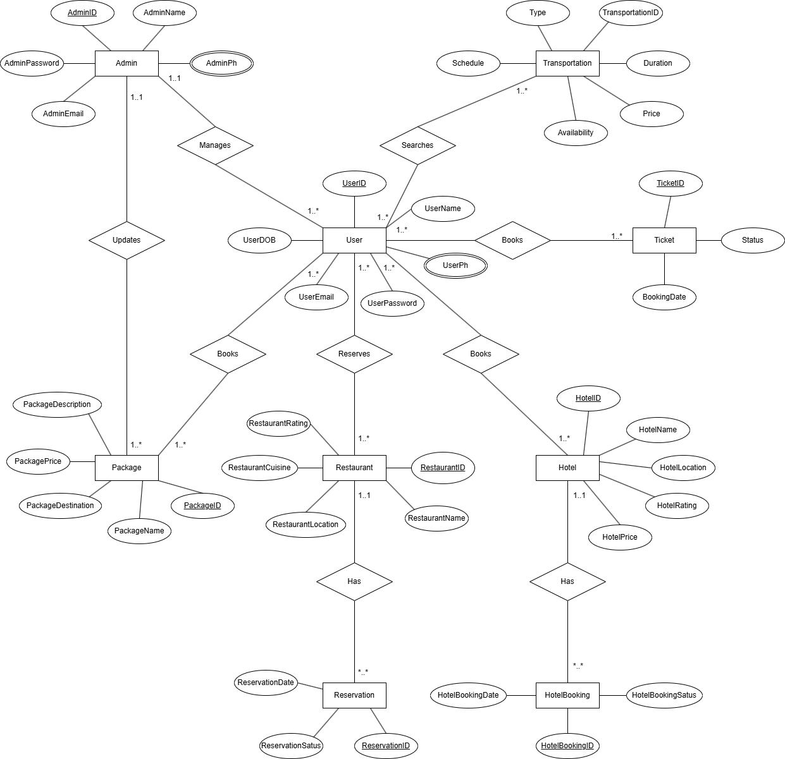

Chapter: 03b

SQL Queries

SELECT TOP (1000) [Name]
,[Username]
,[Password]
,[Email]
,[Phone]
,[DOB]
FROM [LetsTravel].[dbo].[Admin]

SELECT TOP (1000) [CityName]
,[HotelName]
,[TotalPerson]
,[NumberOfDays]
,[CheckIn]
,[CheckOut]
,[Price]
FROM [LetsTravel].[dbo].[Hotel]

SELECT TOP (1000) [Name]
,[UserName]
,[Password]
,[Email]
,[Phone]
,[DOB]
FROM [LetsTravel].[dbo].[Registration]

SELECT TOP (1000) [CityName]
,[ResortName]
,[TotalPerson]
,[NumberOfDays]
,[CheckIn]
,[CheckOut]
,[Price]
FROM [LetsTravel].[dbo].[Resort]

SELECT TOP (1000) [CityName]
,[ResortName]
,[TotalPerson]
,[NumberOfDays]
,[CheckIn]
,[CheckOut]
,[Price]
FROM [LetsTravel].[dbo].[Resort]

SELECT TOP (1000) [CityName]
,[ResortName]
,[TotalPerson]
,[NumberOfDays]
,[CheckIn]
,[CheckOut]
,[Price]
FROM [LetsTravel].[dbo].[Resort]

Chapter: 04

Screenshots

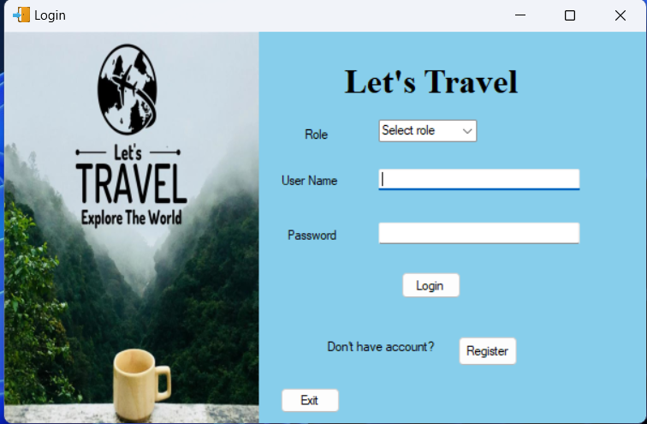

Login Page
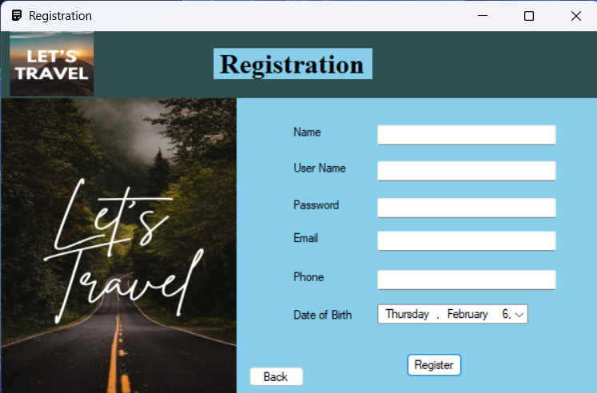

Registration Page

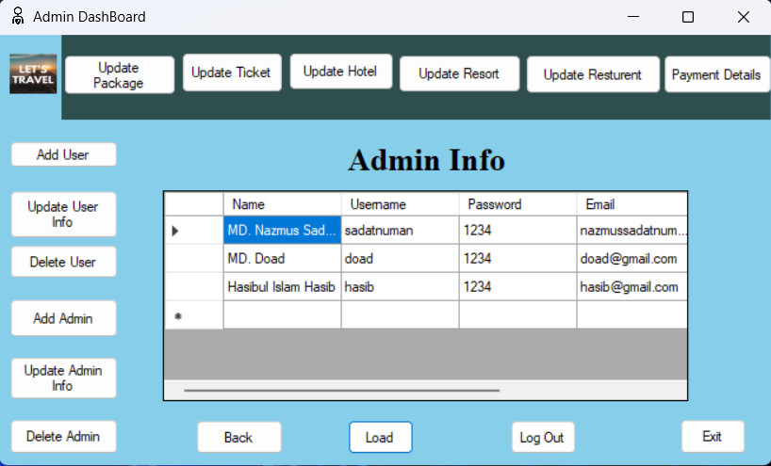

Admin Dashboard

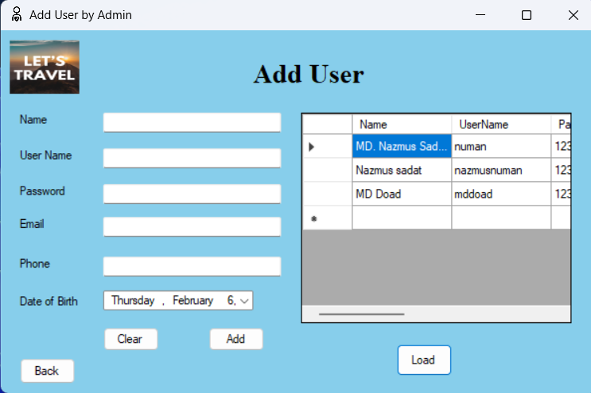

Add User Page

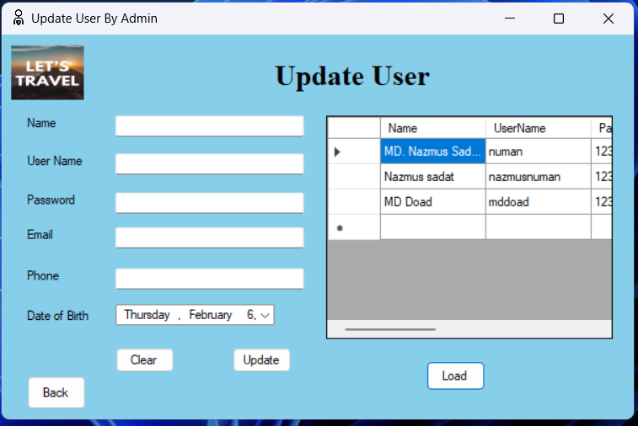

Update User Page

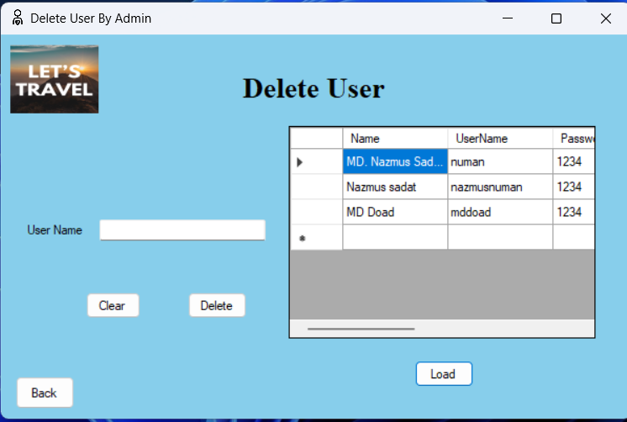

Delete User Page

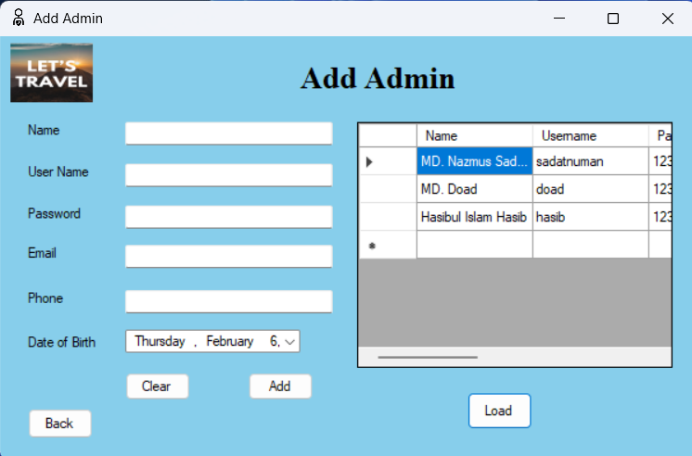

Add Admin Page

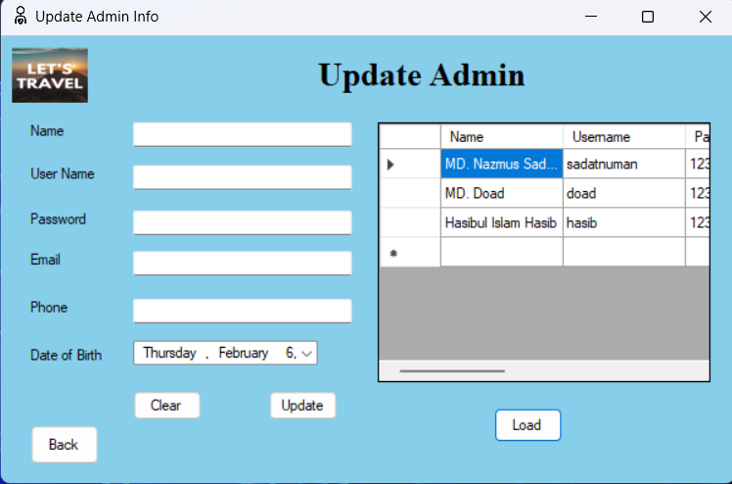

Update Admin Page

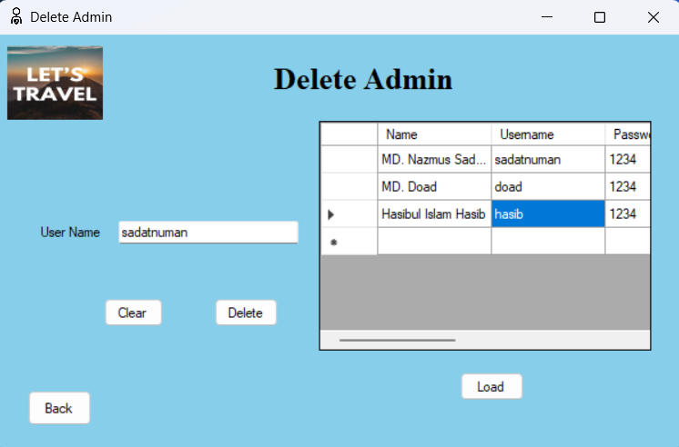

Delete Admin Page

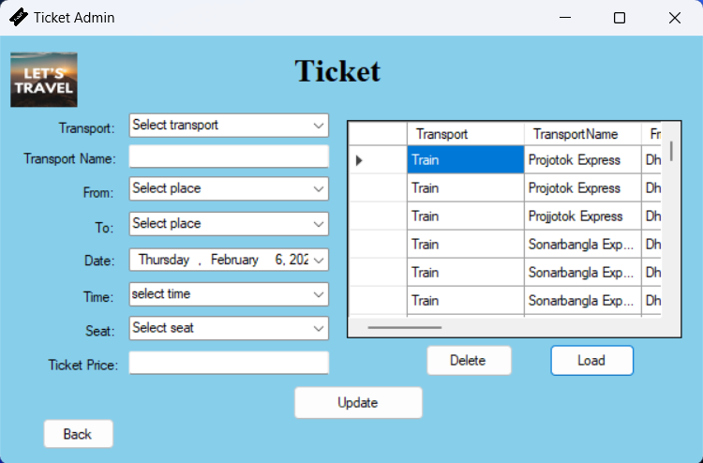

Ticket Update and Delete Page

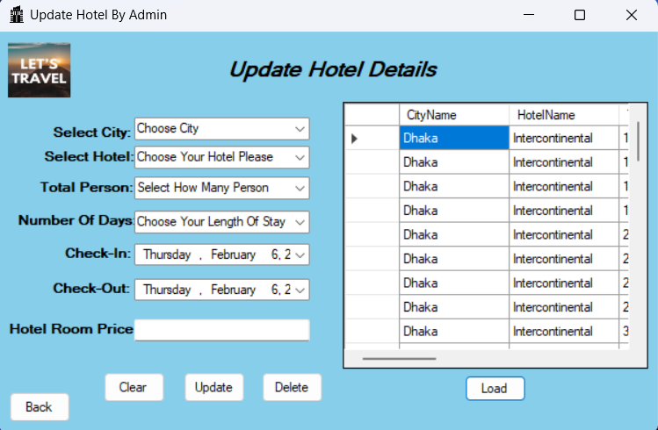

Update and Delete Hotel Details Page

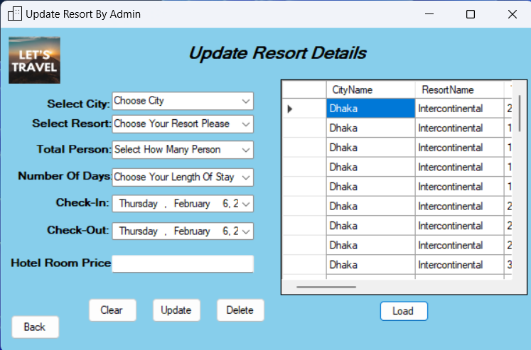

Update and Delete Resort Details

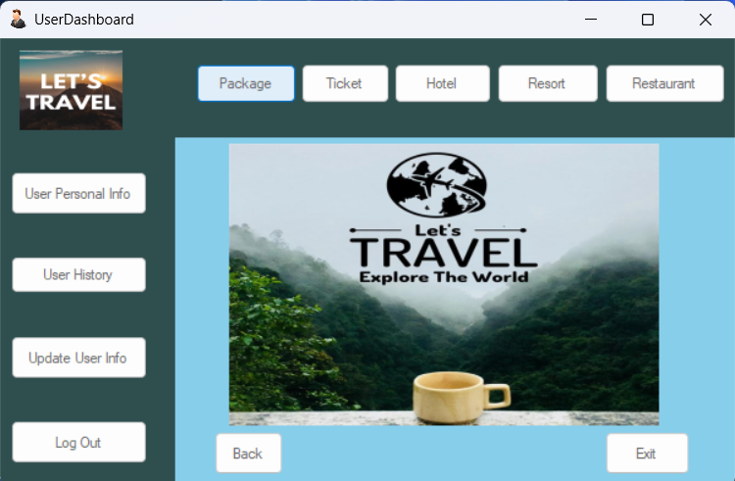

User Dashboard Page

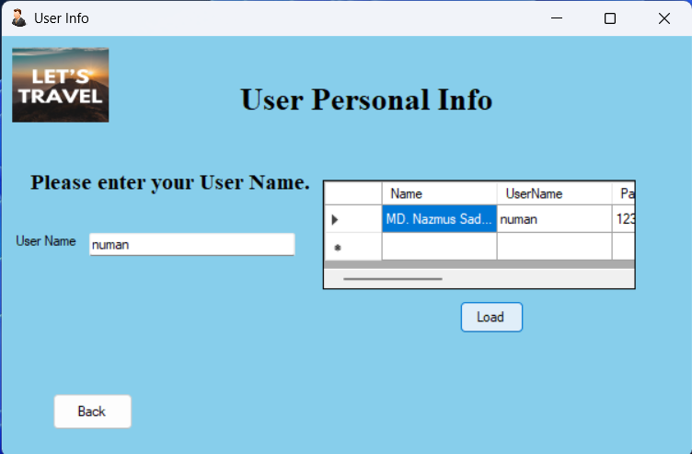

User Information Page

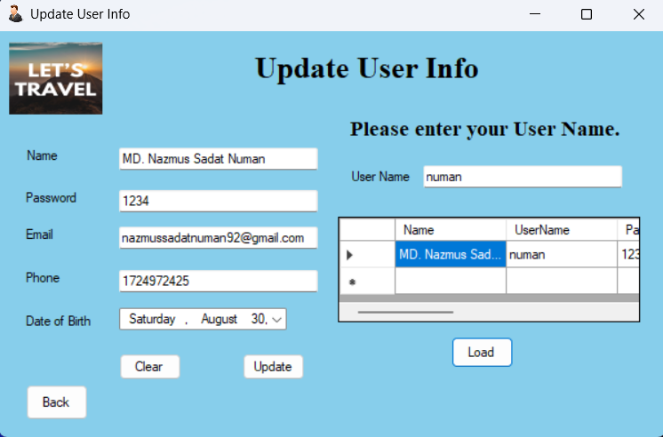

Update User Information Page

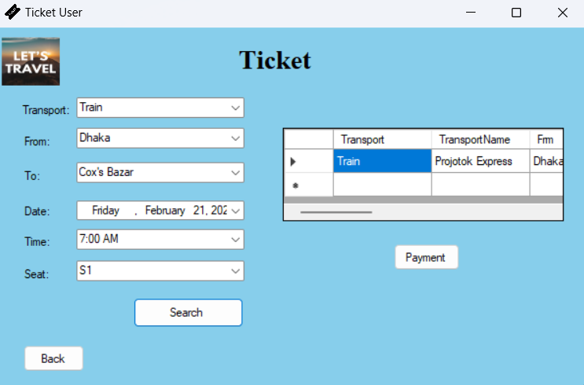

Ticket Purchase Page

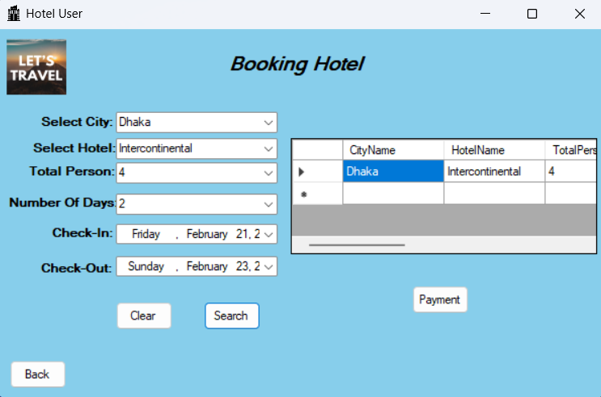

Hotel Booking Page

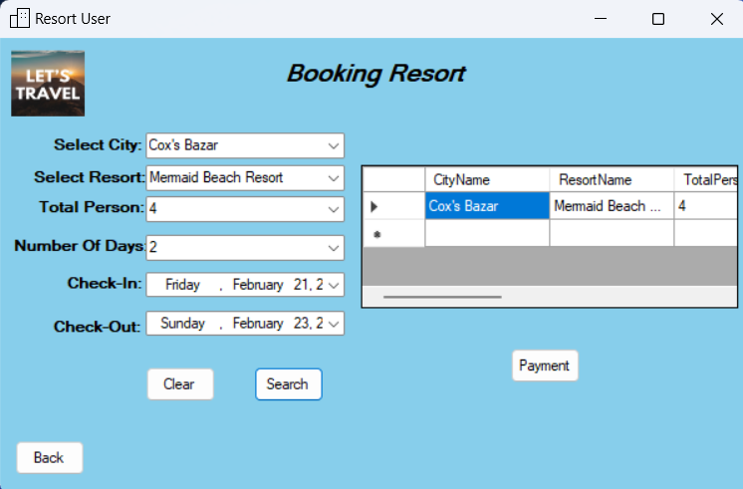

Resort Booking Page

